**Alg 2 13.3 Trig Functions of General Angles** Name ________________________

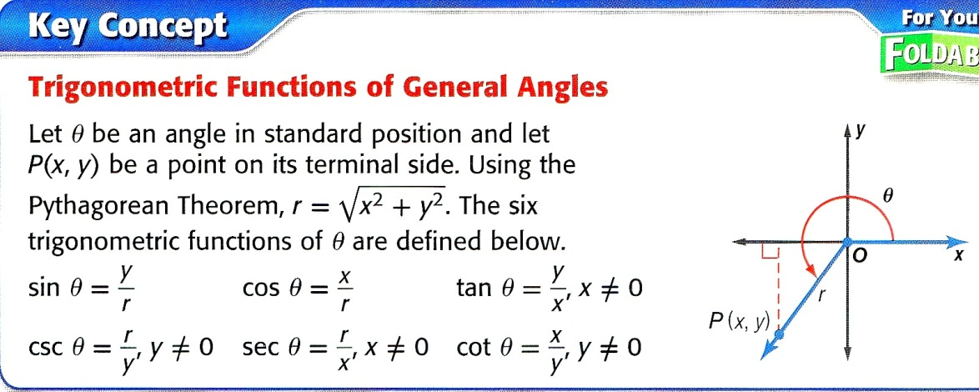

**The terminal side of in standard position contains each point. Find the exact values of the six trigonometric functions of .**

1. (5, 12) 2. (3, 4)

sin = ____ csc = ____

cos = ____ sec = ____

tan = ____ cot = ____

sin = ____ csc = ____

cos = ____ sec = ____

tan = ____ cot = ____

3. (8, –15) 4. (–8, 12)

sin = ____ csc = ____

cos = ____ sec = ____

tan = ____ cot = ____

sin = ____ csc = ____

cos = ____ sec = ____

tan = ____ cot = ____

5. (–9, –40) 6. (1, 2)

sin = ____ csc = ____

cos = ____ sec = ____

tan = ____ cot = ____

sin = ____ csc = ____

cos = ____ sec = ____

tan = ____ cot = ____

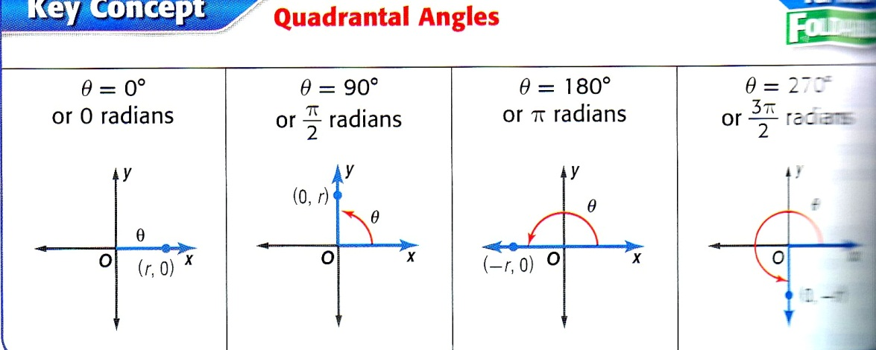

(0, –r)

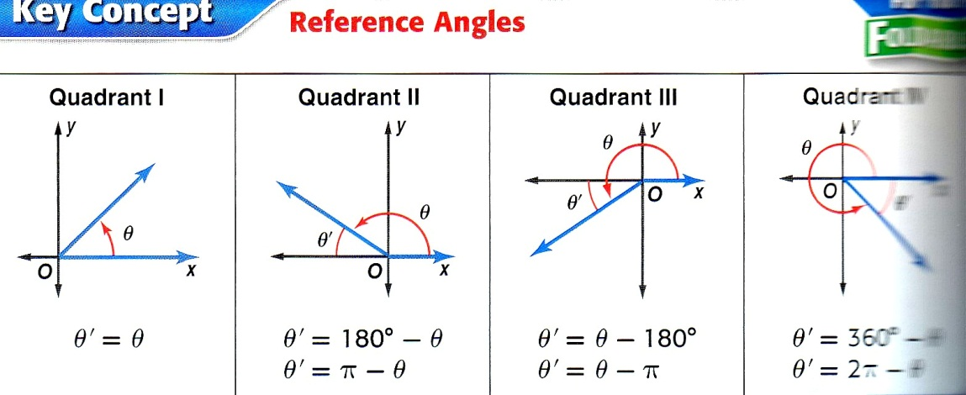

’ = 360 –

’ = 2 –

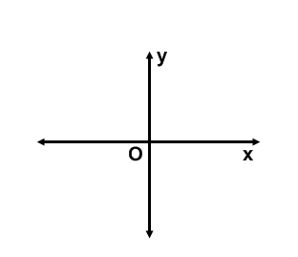**Sketch each angle. Then find its reference angle.**

7. 135 8. 200 9. 

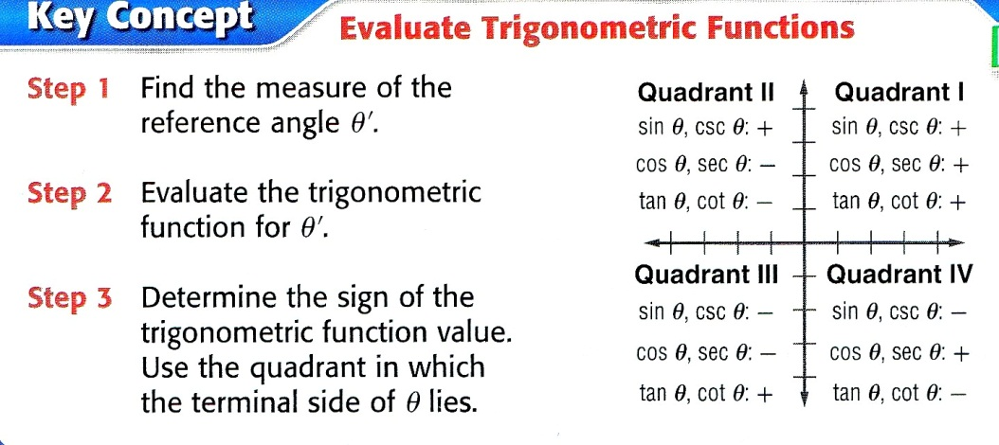

**Find the exact value of each trigonometric function. Use special Rt. Triangles.**

10. sin 150 11. cos 270 12. cot 135 13. tan (–30)

14. tan  15. cos  16. cot  17. sin 