**Alg 2 Sec 13.2 Angles and Angle Measure** Name \_\_\_\_\_\_\_\_\_\_\_\_\_\_\_\_\_\_\_\_\_\_\_\_

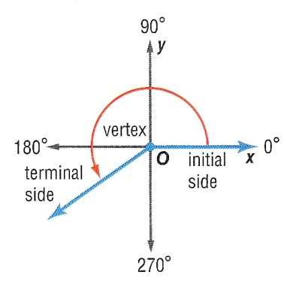**Angles in Standard Position** An angle is determined by two rays. The degree measure of an angle in standard position is described by the amount and direction of rotation from the **initial side**, which lies along the positive *x*-axis, to the **terminal side**. A counterclockwise rotation is associated with positive angle measure and a clockwise rotation is associated with negative angle measure. Two or more angles in standard position with the same terminal side are called **coterminal angles**.

**Draw an angle with measure 210° in standard position.**

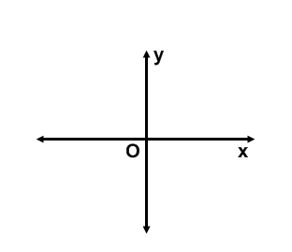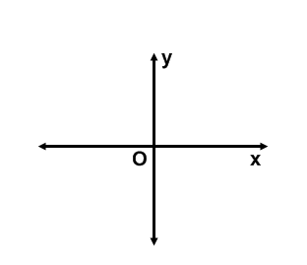

**Draw an angle with the given measure in standard position.**

1. 210 2. 305 3. 580





4. 135 5. –450 6. –560

|  |  |
| --- | --- |
| A positive angle is 250° + 360° or 610°.  A negative angle is 250° − 360° or -110°. | Add 360°.  Subtract 360°. |

**Find an angle with a positive measure and an angle with a negative measure that are coterminal with 250°**

**Find an angle with a positive measure and an angle with a negative measure that are coterminal with each angle.**

7. 65 8. 80 9. 110

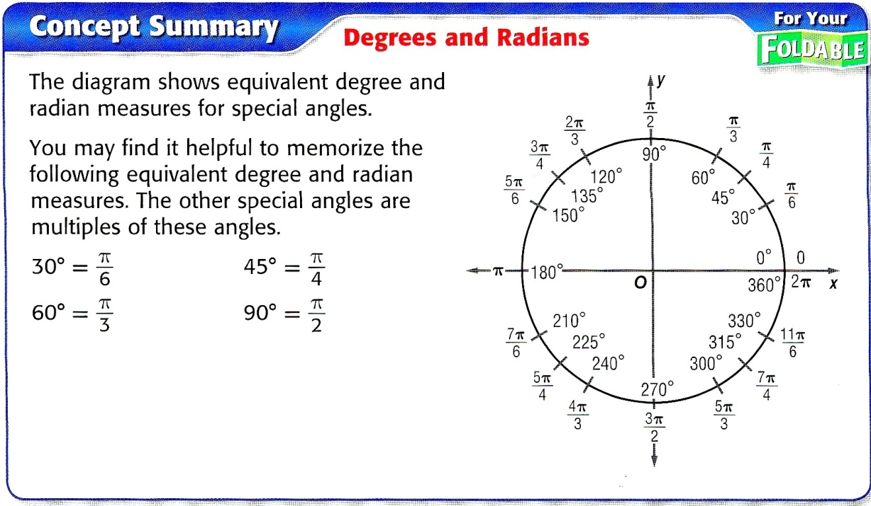

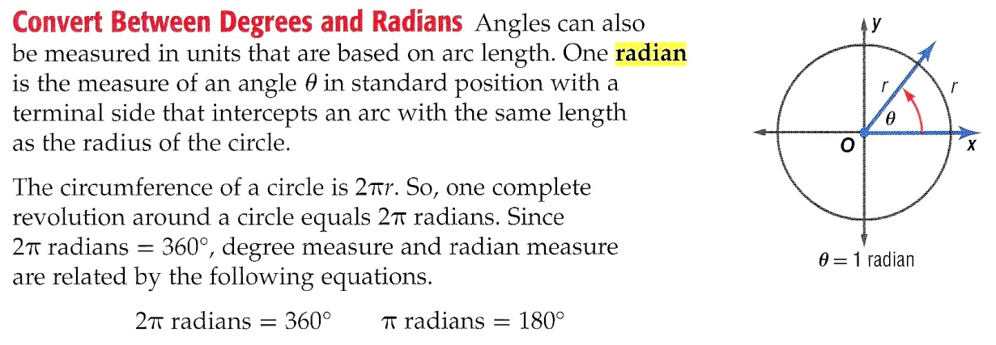

|  |  |
| --- | --- |
| **Radian and Degree Measure** | To rewrite the radian measure of an angle in degrees, multiply the number of radians by E:\media\we\gln_ma_a2crmch13_11-12\images\pg12_001.jpg. To rewrite the degree measure of an angle in radians, multiply the number of degrees by E:\media\we\gln_ma_a2crmch13_11-12\images\pg12_002.jpg. |

**Rewrite each degree measure in radians and each radian measure in degrees.**

10. 18 11. 6 12. –72 13. –820

14.  15.  16.  17. 

**Find an angle with a positive measure and an angle with a negative measure that are coterminal with each angle.**

18.  19.  20. 

**Arc Length and Area of a Sector**

The arc length of a sector is given by the formula \_\_\_\_\_\_\_\_\_\_\_\_\_\_\_\_\_\_\_\_

The area of a sector is given by the formula \_\_\_\_\_\_\_\_\_\_\_\_\_\_\_\_\_\_\_\_\_

**Define the variables:**

s = \_\_\_\_\_\_\_\_\_\_ r = \_\_\_\_\_\_\_\_\_  = \_\_\_\_\_\_\_\_\_\_ A = \_\_\_\_\_\_\_\_\_\_\_

Find the arc length and area of the following sectors:

a). radius = 3 ft and central angle of π/18 b). radius = 9 in and central angle of 60°

Arc Length: \_\_\_\_\_\_\_\_\_\_\_\_\_\_\_\_\_\_\_\_ Arc Length: \_\_\_\_\_\_\_\_\_\_\_\_\_\_\_\_\_\_\_\_

Area of Sector: \_\_\_\_\_\_\_\_\_\_\_\_\_\_\_\_ Area of Sector: \_\_\_\_\_\_\_\_\_\_\_\_\_\_\_\_

c). radius = 2 ft and central angle of 5π/6 d). radius = 4 in and central angle of 55°

Arc Length: \_\_\_\_\_\_\_\_\_\_\_\_\_\_\_\_\_\_\_\_ Arc Length: \_\_\_\_\_\_\_\_\_\_\_\_\_\_\_\_\_\_\_\_

Area of Sector: \_\_\_\_\_\_\_\_\_\_\_\_\_\_\_\_ Area of Sector: \_\_\_\_\_\_\_\_\_\_\_\_\_\_\_\_

e). radius = 6 m and central angle of π/3 f). radius = 5 m and central angle of 135°

Arc Length: \_\_\_\_\_\_\_\_\_\_\_\_\_\_\_\_\_\_\_\_ Arc Length: \_\_\_\_\_\_\_\_\_\_\_\_\_\_\_\_\_\_\_\_

Area of Sector: \_\_\_\_\_\_\_\_\_\_\_\_\_\_\_\_ Area of Sector: \_\_\_\_\_\_\_\_\_\_\_\_\_\_\_\_

21. Find both the degree and radian measures of the angle through which the hour hand on a clock

rotates from 5 A.M. to 10 P.M.

22. A truck with 16 inch radius wheels is driven 77 ft per second (52.5 mph). Find the measure of the

angle through which a point on the outside of the wheel travels each second. Round to the nearest

degree and nearest radian.

23. A sprinkler rotates at an angle of 45° and reaches a length of 24 feet. Find the area of lawn that the sprinkler waters.