**13.1 Trigonometric Functions in Right Triangles** NAME \_\_\_\_\_\_\_\_\_\_\_\_\_\_\_\_\_\_\_\_\_

pg5_002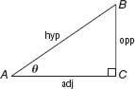

**Find the values of the six trigonometric functions for angle *θ*.**

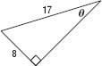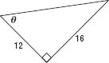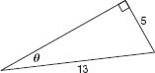1. 2. 3.

sin = \_\_\_\_

cos = \_\_\_\_

tan = \_\_\_\_

csc = \_\_\_\_

sec = \_\_\_\_

cot = \_\_\_\_

sin = \_\_\_\_

cos = \_\_\_\_

tan = \_\_\_\_

csc = \_\_\_\_

sec = \_\_\_\_

cot = \_\_\_\_

sin = \_\_\_\_

cos = \_\_\_\_

tan = \_\_\_\_

csc = \_\_\_\_

sec = \_\_\_\_

cot = \_\_\_\_

**In a right triangle, ∠*A* and ∠*B* are acute.**

4. If , what is cos *A*? 5. If , what is tan *A*? 6. If , what is tan *B*?

7. John stands 150 meters from a water tower and sights the top at an angle of elevation of 36°. How tall is

the tower? Round to the nearest meter.

8. Jessica stands 150 feet from the base of a tall building. She measures the angle from her eye to the top of

the building to be 84°. If her eye level is 5 feet above the ground, how tall is the building?